1) Update the Employees table, so it contains the HireDate values from 2014 till the current (2019) year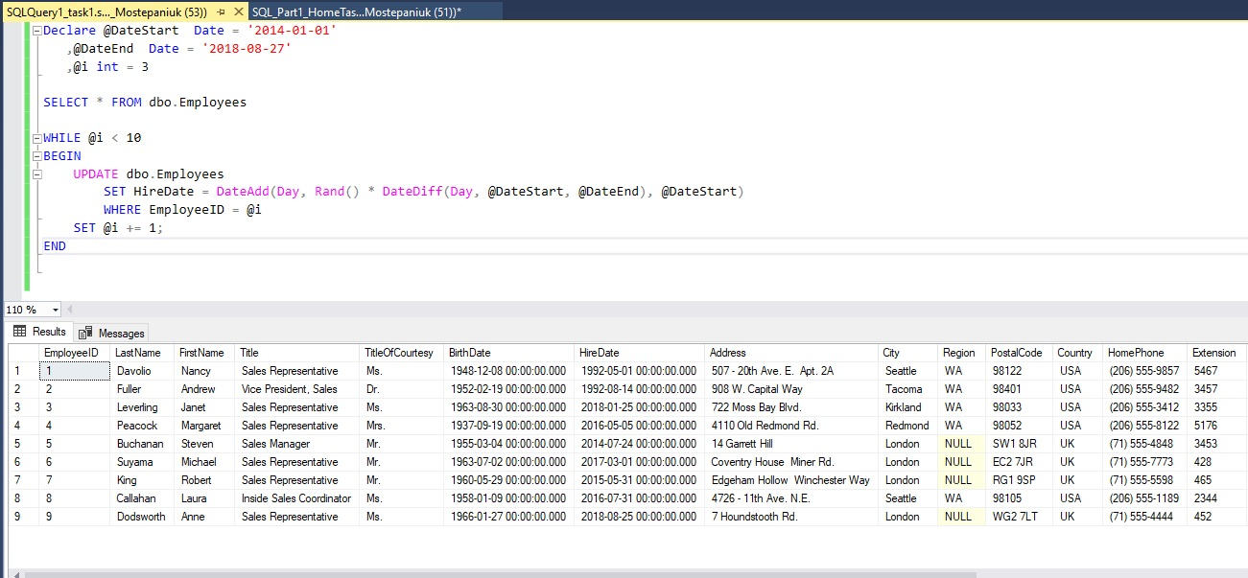

2) Delete records from the Products table where ReorderLevel values is equal to 30. 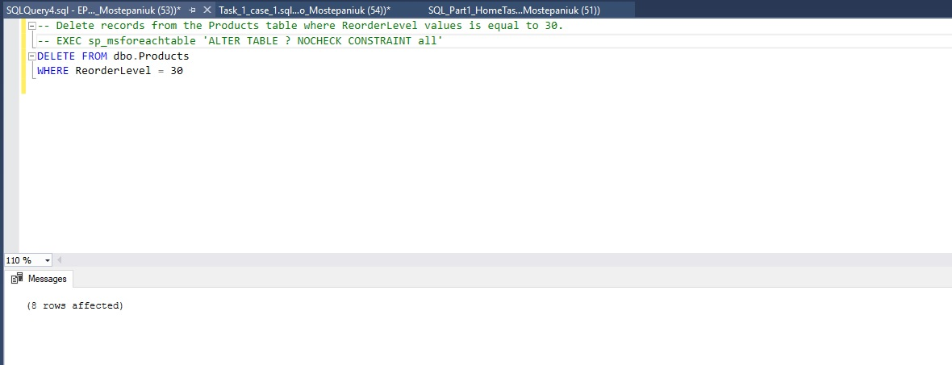

1. Get the list of data about employees: First Name, Last Name, Title, HireDate who was hired this year.

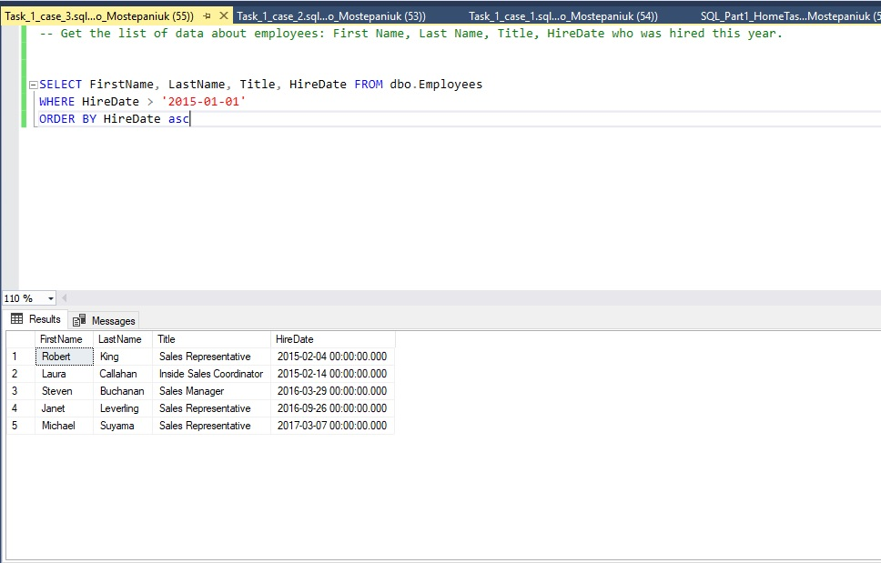

1. Get the list of titles and corresponding employees, who are working in each department (the list of columns in the result set from the Employee table is optional).

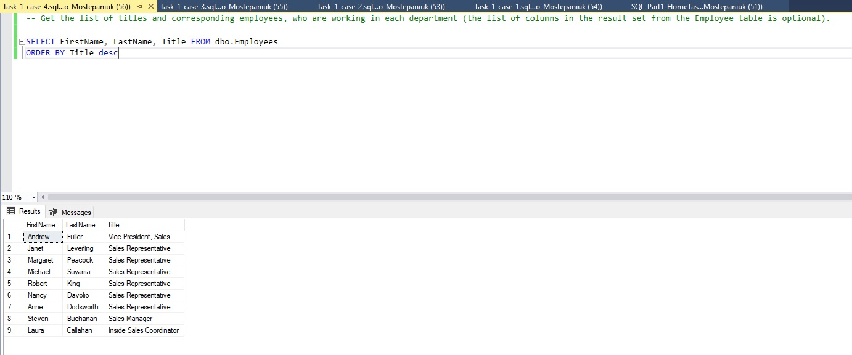

1. Get the list of suppliers, which are located in USA and have a specified region.

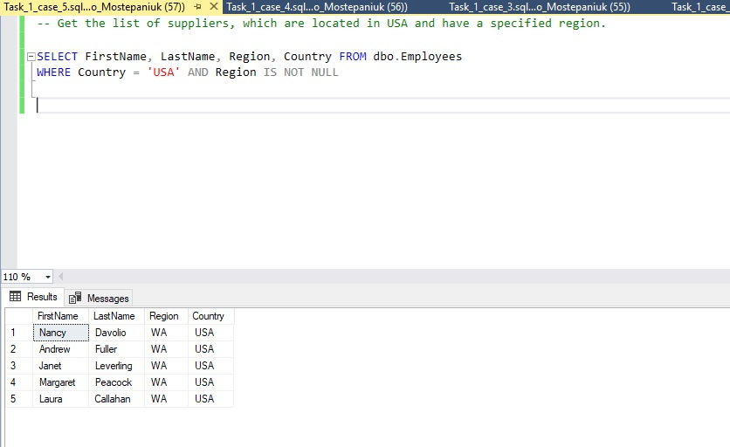

6) Get the amount of products that were delivered by each supplier (company), which have a discount from the Unit Price more than 10%. (order by companyid)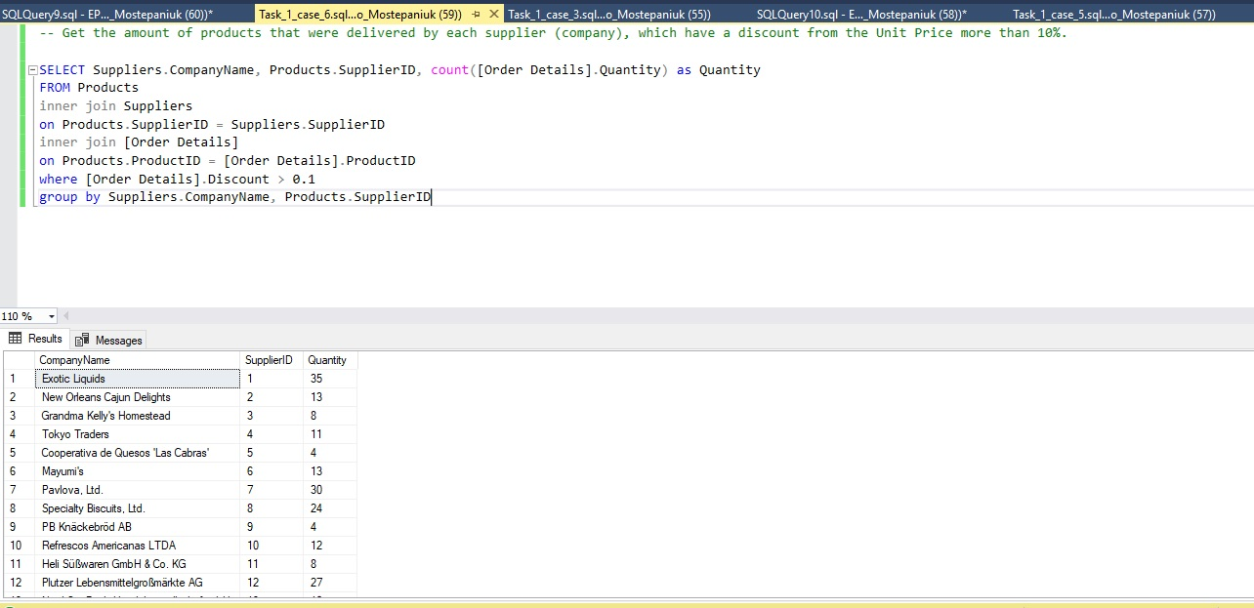

1. Get the top five product categories with the list of the most buyable products in European countries.

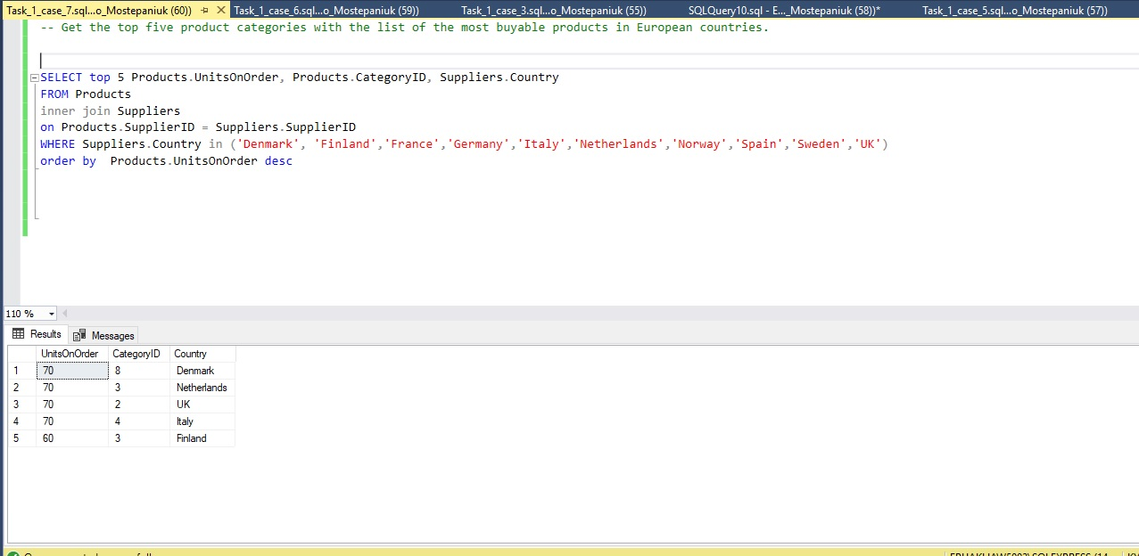

1. Get the First Name, Last Name and Title of Managers and their subordinates.

